**OBTAINING/CONNECTING TO DATA**

1. Download the Data source “Creating a Dashboard in Excel”
   1. Contains a Text file “2018.txt” and a Folder “Sales”
2. Open Excel
3. Click on the **Data** Menu
4. Click on the down arrow in the **New Query** icon
5. Click on **From File**
6. Click on **From Folder**

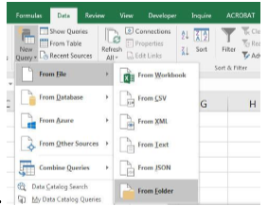

1. Browse for Folder Path and Select the **Start** folder inside **DataAnalytics** folder
2. Click the **Edit** button
3. Under **Query Settings** , in **Properties,** name the Query **Transaction Table**
4. **Right-Click** Content Column and Click on **Remove Other Columns**
   1. Content column contains information about files not the columns in the files.
5. Click Double Downward Pointing arrows.
   1. This process brings in useful column names and information
6. Notice the **Applied steps** Pane

**PREPARING DATA**

1. In the Query Editor, using the Ctrl key, select the Trans#, Web Site, Units, Discount and Price, Right-click and **Remove Columns**
2. Type Field
   1. Click the Drop down filter
   2. Select **Load more**
   3. Filter out the Type
3. Product Field
   1. Click the Drop down filter
   2. Select **Load More**
   3. Filter out **TriFly** (Amounts for this product are too Small for our Analysis)
4. Check each Data Type to make sure that it matches the data in the Field
5. Power Query Home Ribbon Tab, Using the Close group icon, Click on the down arrow and choose Close and Load to:

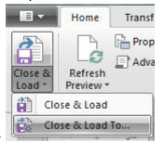

1. Click **Only Create Connection**
2. Check the box next to **Add this data to the** **Data Model**
3. Review Query Pane

**PIVOT TABLE #1 – Revenue by Month & Year**

1. Click the PivotTable button and create a Pivot table on a new sheet
2. Name the new sheet **MonthReport**
3. Observe the Pivot table List shows the Transaction Table from the Data Model
4. Click on the Down arrow to review the Dimensions and Measures
5. Drag **DateTime** field to Row area and a number of new fields are created in the Field List for Year, Month, Quarter:

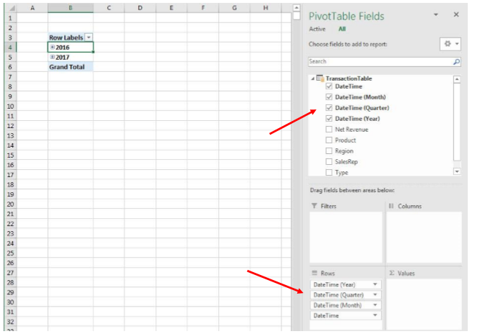

1. Remove **DateTime(Quarter)** fields from Row area.
2. Expand Rows in Pivot table: Right-click and choose, Expand, Expand Entire Field
3. Rename Row Labels in your Pivot table “Month Year”
4. In the field list drag Net Revenue to Values
5. Right-Click Pivot Table and Click on PivotTable Options. Name it. **MonthPivot**

**Adding a Slicer**

We will add a Slicer for Year to the First PivotTable and then later we will attach all the PivotTables to this one Slicer

1. With the cursor in PivotTable, click on the PivotTable Tools Analyze Ribbon tab, then in the filter group click on Insert Slicer
2. Check DateTime(Year) field
3. Edit the slicer in the Slicer Tools Options ribbon
   1. In the ribbon enter 3 into the Columns Box
   2. Resize the Slicer for fit.

**Add chart**

1. Click on the Pivot Table and the in the Insert Ribbon tab, in the Chart group, click on the line Chart
2. For the chart:
   1. Right-click any grey field button and click on **Hide all field buttons on chart**
   2. Delete the Legend
   3. Change the title to Revenue
3. Create a sheet called Dashboard
4. Move the Slicer and the Line chart to the Dashboard Sheet using Cut(ctrl+X and Paste (Ctrl+V)

**PIVOT TABLE #2 - Revenue for each Sales rep**

1. With your cursor on the Dashboard sheet, use the Keyboard to insert a Pivot Table on a new sheet: Alt,N,V
2. Click the **Use this workbooks Data Mod**el dialog button and the **New Worksheet** dialog button
3. Name the sheet SalesRepReport
4. Create PivotTable by dragging **SalesRep** in the Row area and **Net Revenue** Measure in the Values area
5. Right-click in Pivot table and in options Name the pivot table SalesRepPivot
6. On the Dashboard Sheet, Right-click the Slicer and point to **Report connections**, then check the PivotTable SalesRepPivot
7. With your cursor in the SalesRepPivot Table, insert a Clustered Bar Chart

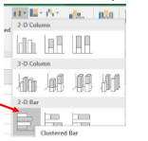

1. For the Bar Chart:
   1. Right-click Grey Field buttons and click on “Hide all field buttons on chart”
   2. Delete the Legend
   3. Delete the horizontal axis
   4. Scroll to upper right hand side of chart and Click on the Green +
      1. Check Data Labels
   5. Then use the Green Plus next to the chart to add “Data Labels”
   6. Click on the Data Labels and use the keyboard Ctrl + 1 to open Task Pane
   7. Select dialog button for “Inside End”
   8. With the Data Labels all selected, in the Home Ribbon Tab in the Font group, select White Font.
   9. Click on the Bars then change Gap width to 50%

Because we want to filter the SalesRep report by Year we need to connect the SalesRep Report to the slicer. This can be done by creating a chart title with the year in it and then linking that to the year. Essentially making the Chart title the filter for the report then linking that chart title to the slicer

1. With a cursor in cell D1 on the “SalesRepReport” Sheet, open the Create PivotTable dialog box with the keyboard: Alt, N, V.
2. In the Create PivotTable dialog box, select **Use this workbook’s Data Model** and “Existing worksheet” dialog buttons.
3. Place the PivotTable in cell D1.
4. From the Field List, drag DateTime (Year) to the Filter Area.
5. Right-click the PivotTable, click on PivotTable Options and then name the PivotTable “YearPivot”.

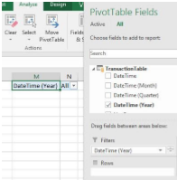

1. On the Dashboard Sheet, Right-click the Slicer and point to “Report Connections”, then check the PivotTable “YearPivot”.
2. Above the Bar Chart create the following formula: =”SalesRep Revenue –“&E1
3. With Chart Title selected (make sure solid line is around Chart title (not dotted line)), link Chart Title to by clicking on = then choosing the cell where you created the formula in step 15

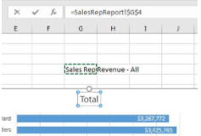

* 1. Chart now, has a Chart Title that is linked to the “YearPivot”, which is in turn linked to the Year Slicer

1. Move the Bar Chart to the Dashboard Sheet using Cut (Ctrl + X) and Paste (Ctrl + V)

**CREATE CROSSTAB**

1. With a cursor in an empty cell on the “Dashboard” Sheet, open the Create PivotTable dialog box with the keyboard: Alt, N, V.
2. In the Create PivotTable dialog box, select “Use this workbook’s Data Model” and “New Worksheet” dialog buttons and then hit Enter (or click OK).
3. Name the Sheet “CrossTabReport”.
4. Create the following PivotTable with DateTime (Years) in Filter area, Region in Column area, Product in Rows area and the Net Revenue Measure in the Values area:
5. Right-click the PivotTable, click on PivotTable Options and then name the PivotTable “CrossTabPivot”.
6. On the Dashboard Sheet, Right-click the Slicer and point to “Report Connections”, then check the PivotTable “CrossTabPivot”.
7. Back on the CrossTabReport sheet, Click in cell B5 and then go to the Home Ribbon Tab, Styles group, Conditional Formatting drop-down, Top/Bottom Rules and Top 10 Items:

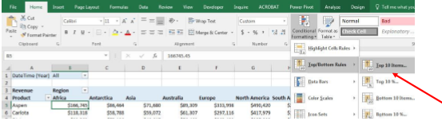

1. Change the “top” to 20 and add the formatting you want, then click OK:
2. Click Smart Tag and click on “All cells showing “Revenue” values for “Product” and “Region”:

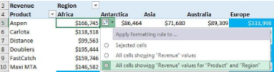

1. In the View Ribbon Tab, in Show group, uncheck Gridlines.
2. Highlight the entire Cross Tab PivotTable, including the Filter area And then copy with Ctrl + C.
3. On the “Dashboard” Sheet, click in a cell below the other Charts and then go to the Clipboard group in the Home Ribbon Tab
4. Click the Paste button drop-down and the click on the lower right corner icon for “Linked Picture”:

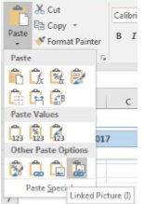

ADD New Text files to Folder and Refresh Dashboard

1. From your Data Analytics folder Drag and Drop 2018 Text file into start folder
2. In the Data Ribbon Tab, click the Refresh All (Ctrl + Alt + F5):

Format Dashboard using align and colors to make it pop.